**Map**

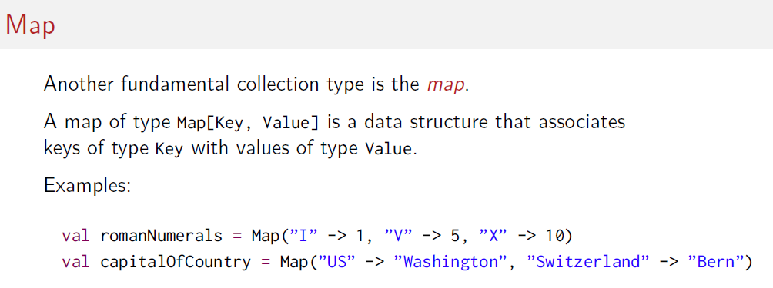

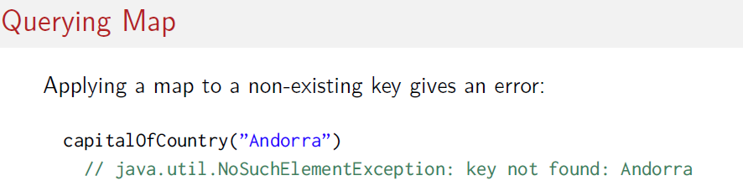

**Map internal structure Key, value. Where value can be something of wrapped in class Option**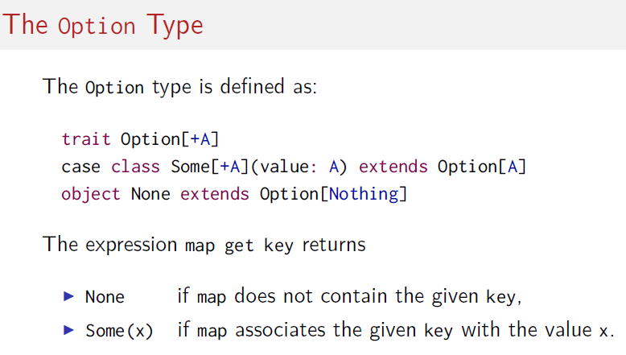

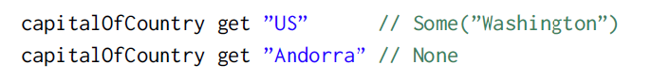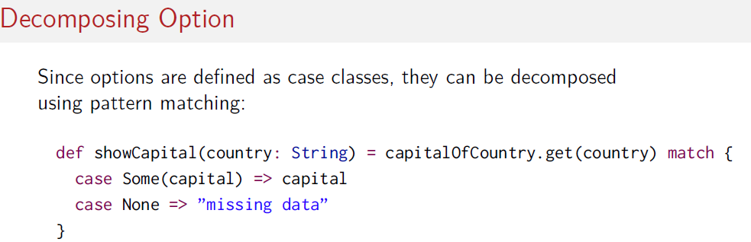

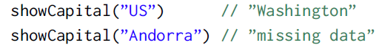

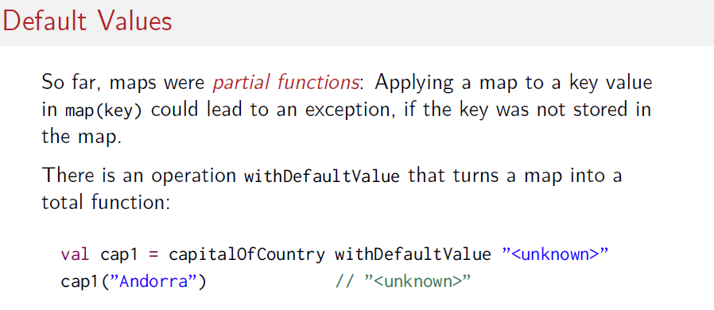

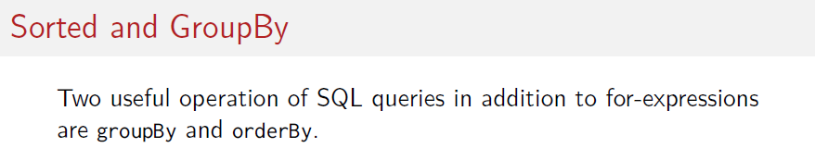

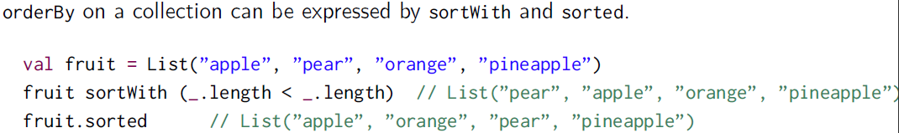

**Note that sortWith use _ to referer to each function parameter. in this case ( leftE,rightE )**   
personList.sortWith{ ( leftE,rightE ) => leftE.age > rightE.age } 4  
 more simply:   
personList.sortWith(_.age > _.age) 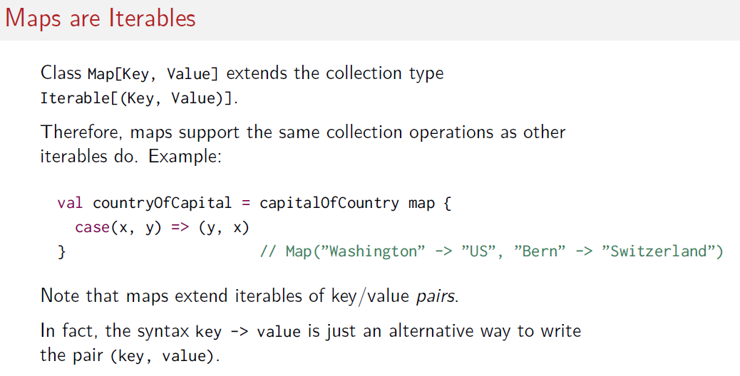

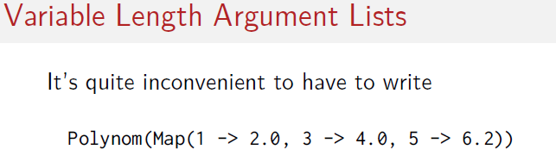

It can be reduced to

by adding a new constructor with repeated parameters using the * . Then it can be converted to a Map.

